2.CRUD operations in Git

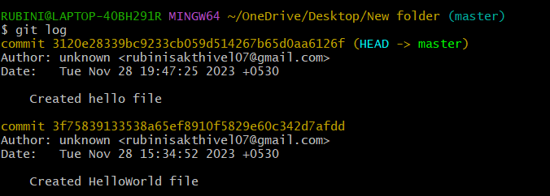

Reverting the previous commits

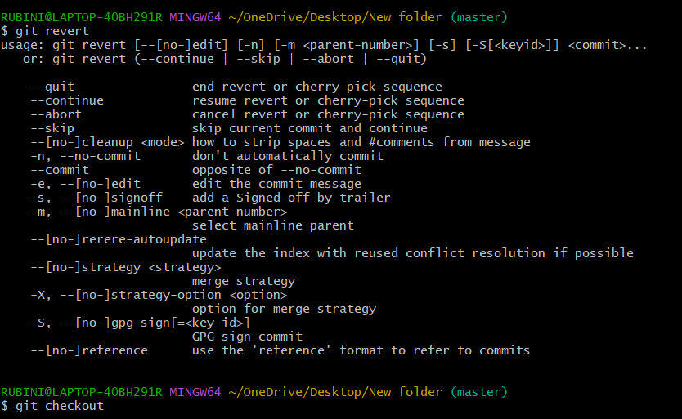

Pulling the commits and collaborating between the local and remote repositories.

